Murodjon Abdurashidov 4250 group

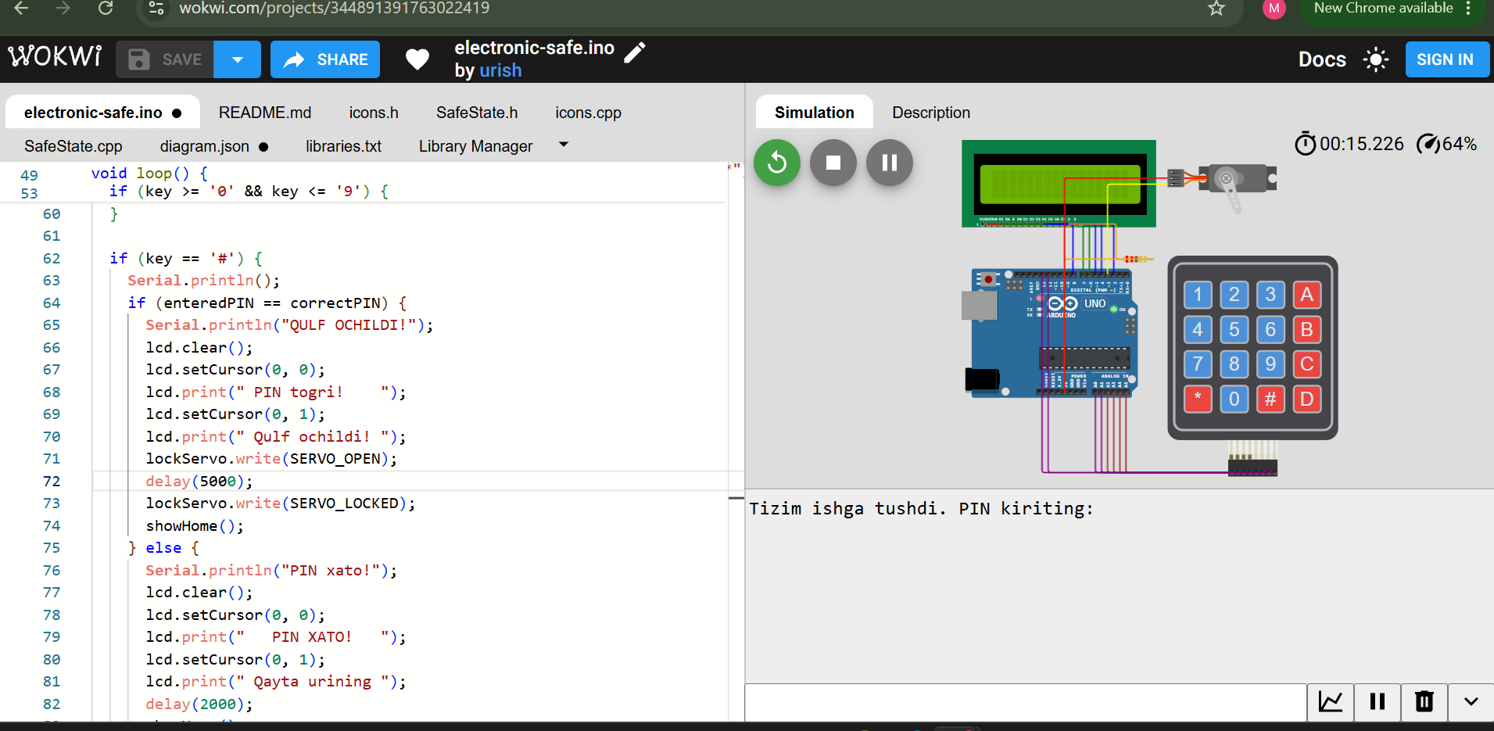
ArduinoSafe v2.0 is a PIN-protected electronic lock system built with Arduino Uno. The user enters a 4-digit PIN code using a 4x4 membrane keypad. If the PIN is correct, a servo motor unlocks the door by rotating downward and automatically locks again after 5 seconds. A 16x2 LCD display guides the user through each step, showing status messages such as welcome screen, PIN input feedback, access granted, and access denied. The project is fully simulated on Wokwi and demonstrates basic embedded systems concepts including digital I/O, SPI communication, servo control, and user interface design.

